**ArcGIS GIS Server Connection**

1. **In ArcCatalog add the server**

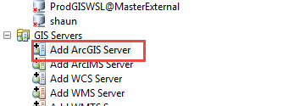

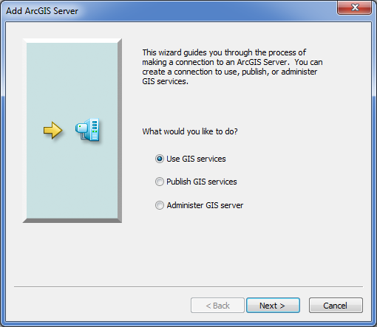

Paste the url as shown below:

<https://wsldctpgweb.water.internal/server/services>

